Use Case: View SFQ of enrolled course and Instructor

Brief Description

This use case describes how a student view the SFQ of the enrolled course or all Instructor

Use-case Diagram

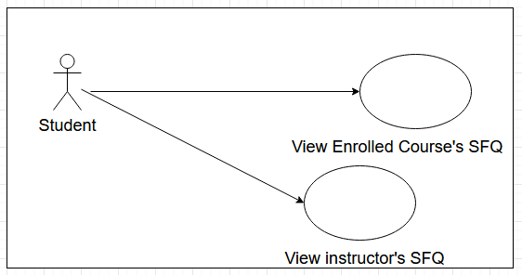

Basic Flow

1. The use case begins when the student actor chooses to view SFQ of all Instructor or his enrolled courses.
2. The system displays the interface for viewing the SFQ of all Instructor and enrolled courses.
3. While the student has an activity to perform
   1. If Find SFQ with my enrolled courses activity can select and is selected

{Begin Search Enrolled Course SFQ}

3.1.1 The system retrieves and displays the average unadjusted SFQ data of the enrolled course

3.2 If List instructors’ average SFQ is selected

3.2.1 The system retrieves and displays the average unadjusted SFQ score of all instructor

Alternative Flows

A1: Invalid Enrolment

At {Begin Search Enrolled Course SFQ} if Enrolment cannot be correctly implemented in List.

1. The system checks scrapped data.
   1. If there are more than or exactly 5 sections of scrapped data.
      1. The system enrolls the first 5 sections of the scrapped data.
   2. If there are less than 5 sections of scrapped data.
      1. The system enrolls the all sections of the scrapped data.
2. The flow of the events is resumed at {Begin Search Enrolled Course SFQ}.

A2: Check search or all subject search is clicked

At any time in the flow of events

1. The system checks whether search or all subject search is clicked
   1. If search or all subject search is not clicked
      1. Disable activity Find SFQ with my enrolled courses
   2. If search or all subject search is clicked
      1. Enable activity Find SFQ with my enrolled courses